CO2 AT2 - SCENARIO-BASED QUESTIONS

Name: ADHITHYA.S

Register Number: 192412352

Course Code: ITA0606

Course Name: MACHINE LEARNING

6. Decision Tree Learning System

Architecture
A decision tree consists of a root node (the first, most informative attribute test), internal (decision) nodes that test further attributes, branches that represent the outcome of a test, and leaf nodes that hold the final class label. Prediction for a new instance is made by following the branch matching its attribute values from the root down to a leaf.
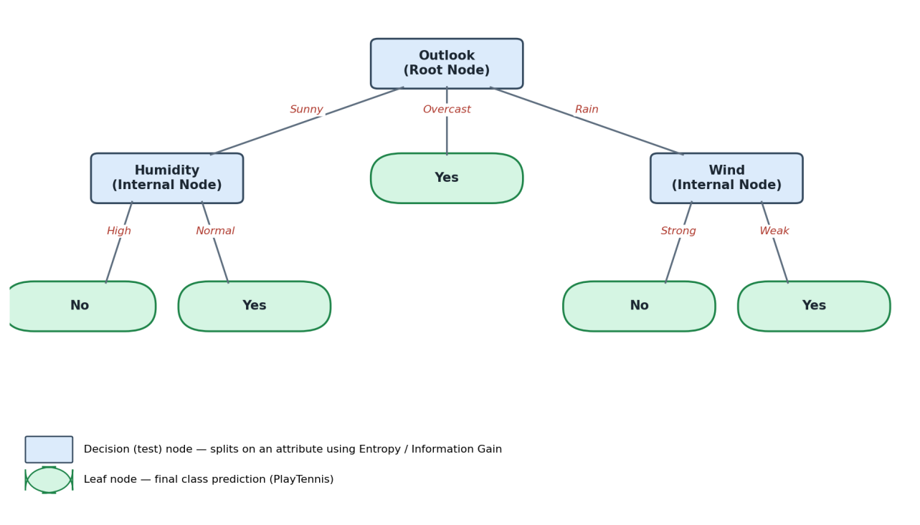

Feature Selection: Entropy and Information Gain
Entropy measures the impurity/disorder of a set S with respect to the target class:
Entropy(S) = − Σ pᵢ log₂(pᵢ) (sum over each class i, pᵢ = proportion of class i in S)
Information Gain measures the reduction in entropy achieved by splitting S on attribute A:
Gain(S, A) = Entropy(S) − Σ (|Sᵥ| / |S|) × Entropy(Sᵥ) (sum over each value v of A)
At each node, the decision tree algorithm (e.g., ID3/C4.5) computes the Information Gain for every candidate attribute and selects the attribute with the highest gain as the splitting test, since it produces the purest (most homogeneous) child subsets.

Worked Example — "PlayTennis" Dataset (Outlook attribute)
Day | Outlook | PlayTennis
1 | Sunny | No
2 | Sunny | No
3 | Overcast | Yes
4 | Rain | Yes
5 | Rain | Yes
6 | Rain | No
7 | Overcast | Yes
8 | Sunny | Yes

- Overall set S: 5 Yes, 3 No out of 8 ⇒ Entropy(S) = −(5/8)log₂(5/8) − (3/8)log₂(3/8) = 0.424 + 0.531 = 0.955 bits.
- Sunny {No, No, Yes}: Entropy = 0.918; Overcast {Yes, Yes}: Entropy = 0 (pure); Rain {Yes, Yes, No}: Entropy = 0.918.
- Weighted entropy after split = (3/8)(0.918) + (2/8)(0) + (3/8)(0.918) = 0.689 bits.
- Information Gain(Outlook) = 0.955 − 0.689 = 0.266 bits.
Outlook is compared against the other attributes (Humidity, Wind, Temperature) in the same way; whichever gives the highest gain becomes the root. Here Outlook is chosen as the root — the Overcast branch is already pure (leaf = Yes), while the Sunny and Rain branches are split further (on Humidity and Wind respectively) using the same entropy/gain procedure, recursively, until all leaves are pure or a stopping criterion is met.

Pruning
- Pre-pruning (early stopping): stop splitting a node early using constraints such as maximum depth, minimum samples per leaf, or a minimum information-gain threshold.
- Post-pruning: grow the full tree first, then remove (collapse) branches that do not improve accuracy on a separate validation set — common methods include Reduced-Error Pruning and Cost-Complexity Pruning.

Controlling Overfitting
- Limit tree depth (max_depth) and set a minimum number of samples required to split a node or form a leaf.
- Apply pruning (pre- or post-pruning) to remove branches that fit noise rather than genuine patterns.
- Use cross-validation to tune these hyperparameters objectively.
- Use ensemble methods (Random Forest, Gradient Boosting) which average many trees to reduce the variance/overfitting of any single tree.

7. Machine Learning System for Smart Traffic Congestion Prediction

Problem Definition
Predict traffic congestion level (e.g., Low/Medium/High, or a continuous congestion index) at a road segment using vehicle density, time of day, weather conditions, and road type — a supervised classification or regression problem, generally with a strong time-series component.

Choice of Algorithm and Justification
Algorithm | Why suitable
Random Forest / Gradient Boosting (XGBoost) | Handles mixed numeric (density, time) and categorical (weather, road type) features well, captures non-linear interactions, robust and fast enough for near-real-time scoring.
LSTM / GRU (Recurrent Neural Network) | Traffic congestion is sequential/time-dependent (rush hours, recurring daily patterns) — recurrent architectures capture temporal dependencies across recent time steps better than static models.
Hybrid approach | Use gradient-boosted trees for fast, interpretable short-term prediction on structured features, and an LSTM for longer sequence/time-pattern modelling where historical trends matter most; ensemble/average their outputs for the deployed system.

Preprocessing and Feature Engineering
- Clean sensor/GPS data: remove duplicate or erroneous readings, impute missing vehicle-density values (interpolation for short gaps).
- Encode categorical variables: one-hot encode weather condition and road type.
- Time features: extract hour-of-day, day-of-week, and weekend/holiday flags; use cyclical encoding (sin/cos) for hour and day so the model understands that 23:00 and 00:00 are close.
- Engineer lag and rolling features: vehicle density over the last 15/30/60 minutes, rolling average speed, to capture recent trend.
- Scale numeric features (density, speed) using standardization, especially if using neural network components.

Training, Validation, and Deployment
- Use a time-based (chronological) train/validation/test split rather than random shuffling, since future data must not leak into training.
- Apply time-series cross-validation (rolling-origin) for hyperparameter tuning.
- Evaluate with regression metrics (RMSE, MAE) if predicting a continuous congestion index, or classification metrics (accuracy, F1) if predicting congestion categories.
- For deployment: expose the trained model as a low-latency API/microservice that ingests live sensor/GPS streams, generates rolling predictions (e.g., every 1–5 minutes), and feeds results to traffic-signal control or driver-facing navigation systems.
- Set up continuous monitoring for data drift (e.g., road construction, new routes) and scheduled retraining with fresh data to keep predictions accurate over time.

8. Convolutional Neural Networks (CNNs)

Architecture
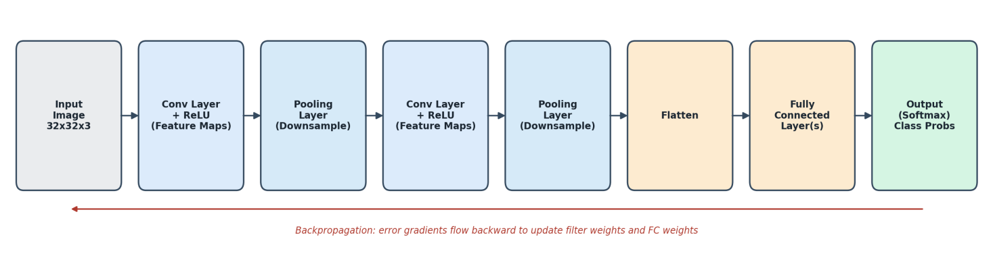

Key Layers
Layer | Role
Convolutional Layer | Slides a set of learnable filters (kernels) across the input, computing a dot product at each position to produce feature maps that highlight patterns such as edges, textures, or shapes. Followed by a non-linear activation (ReLU) to introduce non-linearity.
Pooling Layer | Downsamples each feature map (e.g., Max Pooling takes the maximum value in each window) — reduces spatial dimensions and computation, and provides a degree of translation invariance.
Fully Connected (FC) Layer | After flattening the final feature maps into a vector, one or more dense layers combine all extracted features to perform the final classification, ending in a Softmax layer that outputs class probabilities.

Generating Feature Maps
Each filter (e.g., 3×3 or 5×5) is convolved across the width and height of the input volume: at every position, an element-wise multiplication between the filter weights and the underlying input patch is summed to produce one output value. Repeating this across the whole input produces a 2-D feature map for that filter; using multiple filters in a layer produces multiple feature maps stacked into a 3-D output volume, each capturing a different pattern.

Backpropagation in CNNs
- The loss computed at the output layer is propagated backward through the FC layers using standard backpropagation (chain rule) to compute gradients with respect to FC weights.
- Through pooling layers, gradients are routed back only to the input position that produced the max value (for Max Pooling) or distributed evenly (for Average Pooling).
- Through convolutional layers, the gradient with respect to each filter weight is computed as the convolution of the input feature map with the incoming gradient (error) signal; gradients are also propagated further back using the flipped/transposed filters.
- All weights (filters and FC weights) are then updated using gradient descent (or a variant such as Adam) scaled by the learning rate.

Example — Image Classification
For classifying handwritten digits (e.g., MNIST, 28×28 grayscale images): Conv Layer 1 (e.g., 32 filters, 3×3) detects low-level edges/strokes → ReLU → Pooling reduces size → Conv Layer 2 detects higher-level shapes (loops, curves that make up digits) → ReLU → Pooling → Flatten → Fully Connected layer combines these high-level features → Softmax outputs a probability for each digit class (0–9), and the class with the highest probability is the prediction.

Factors Affecting Model Performance
- Quantity and quality of labeled training data; class balance.
- Network depth and filter/kernel sizes — too shallow underfits, too deep without enough data can overfit.
- Learning rate and optimizer choice — poor settings cause slow or unstable convergence.
- Regularization techniques used (Dropout, Batch Normalization, weight decay) to control overfitting.
- Data augmentation (rotation, flipping, cropping) to improve generalization on limited data.
- Computational resources (GPU memory/time), which constrain batch size and achievable model size.

9. Genetic Algorithms for Feature Selection

Chromosome Representation
Each candidate feature subset is represented as a binary chromosome of length equal to the total number of available features, where bit i = 1 means feature i is included in the subset and bit i = 0 means it is excluded. For example, with 6 features, the chromosome 1 0 1 1 0 0 represents a subset containing features 1, 3, and 4 only.

Fitness Evaluation
- For each chromosome, train the target ML model (e.g., a classifier) using only the features flagged as 1, and evaluate it on a validation set.
- Fitness is typically the model's performance metric (accuracy, F1-score, or AUC) on that subset, often combined with a small penalty for the number of features selected, so the GA favors compact, high-performing subsets: Fitness = Performance − λ × (number of features selected).

Selection, Crossover, and Mutation
- Selection: chromosomes (feature subsets) with higher fitness are more likely to be chosen as parents for the next generation, using methods such as roulette-wheel or tournament selection — mimicking survival of the fittest.
- Crossover: two parent chromosomes exchange segments of their bit strings (single-point or multi-point crossover) to produce offspring subsets that combine useful features from both parents, exploring new combinations.
- Mutation: randomly flips a small number of bits (toggling a feature in/out) with low probability, maintaining diversity in the population and allowing the search to escape local optima by trying feature combinations that crossover alone would not generate.
These three operators are applied over many generations, progressively evolving the population toward feature subsets with higher fitness.

How This Improves Accuracy and Reduces Complexity
- Removes irrelevant or redundant features that add noise and can mislead the model, which typically improves predictive accuracy.
- Reduces the dimensionality of the input, which lowers training time, memory usage, and the risk of overfitting (fewer parameters relative to the amount of data).
- Produces a smaller, more interpretable feature set, making the resulting model easier to understand, explain, and maintain — without needing to exhaustively evaluate every possible feature subset (which is computationally infeasible for large feature counts).

10. Evaluation Metrics for Classification Problems

Sample Confusion Matrix (illustrative fraud-detection example)
 | Predicted Fraud | Predicted Legit | Total (Actual)
Actual Fraud | TP = 80 | FN = 40 | 120
Actual Legit | FP = 30 | TN = 850 | 880

Total samples = 80 + 850 + 30 + 40 = 1000

Metric Calculations
Metric | Formula | Calculation | Result
Accuracy | (TP+TN)/Total | (80+850)/1000 | 0.93 = 93%
Precision | TP/(TP+FP) | 80/110 | 0.727 = 72.7%
Recall (Sensitivity) | TP/(TP+FN) | 80/120 | 0.667 = 66.7%
F1-score | 2×(P×R)/(P+R) | 2×(0.727×0.667)/(0.727+0.667) | 0.696 = 69.6%

ROC Curve
The ROC (Receiver Operating Characteristic) curve plots the True Positive Rate (Recall) against the False Positive Rate (FP / (FP+TN)) at every possible classification threshold. The Area Under the Curve (AUC) summarizes performance across all thresholds into a single number (1.0 = perfect, 0.5 = random guessing) — it is especially useful because it does not depend on choosing one fixed threshold, unlike accuracy/precision/recall which are all threshold-specific.

Why These Metrics Matter in Practice
- Accuracy alone is misleading here — a naive model that always predicts "Legit" would score 88% accuracy (880/1000) despite catching zero fraud cases, because the classes are imbalanced. This shows why accuracy should never be used alone on imbalanced problems like fraud or disease detection.
- Medical diagnosis: Recall/Sensitivity is usually prioritized — missing an actual disease case (false negative) can be life-threatening, so the model should minimize FN even if it means accepting more false positives (which just trigger further tests).
- Fraud detection: both Precision and Recall matter — low precision means legitimate customers are frequently flagged (poor experience, wasted investigation effort), while low recall means fraud goes undetected (direct financial loss); F1-score balances the two, and ROC-AUC is used to compare models independent of the exact threshold chosen, which is often tuned separately based on business cost trade-offs.

